***Exercise # 04***

**Name: M. Tahir**

**Roll. No.: 21K-4503**

**Section: 2-E**

**Question # 04**

**Truth Table**

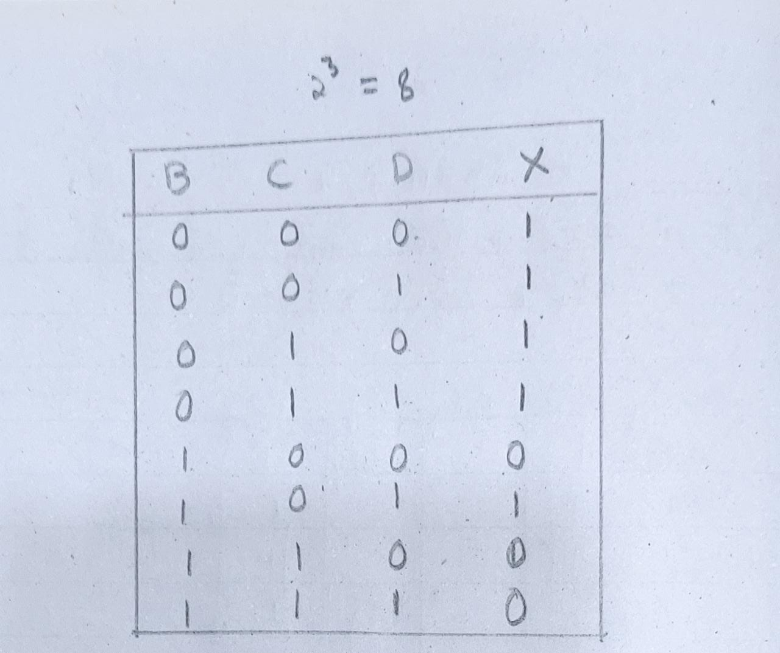

**Minimized SOP on Logisim:**

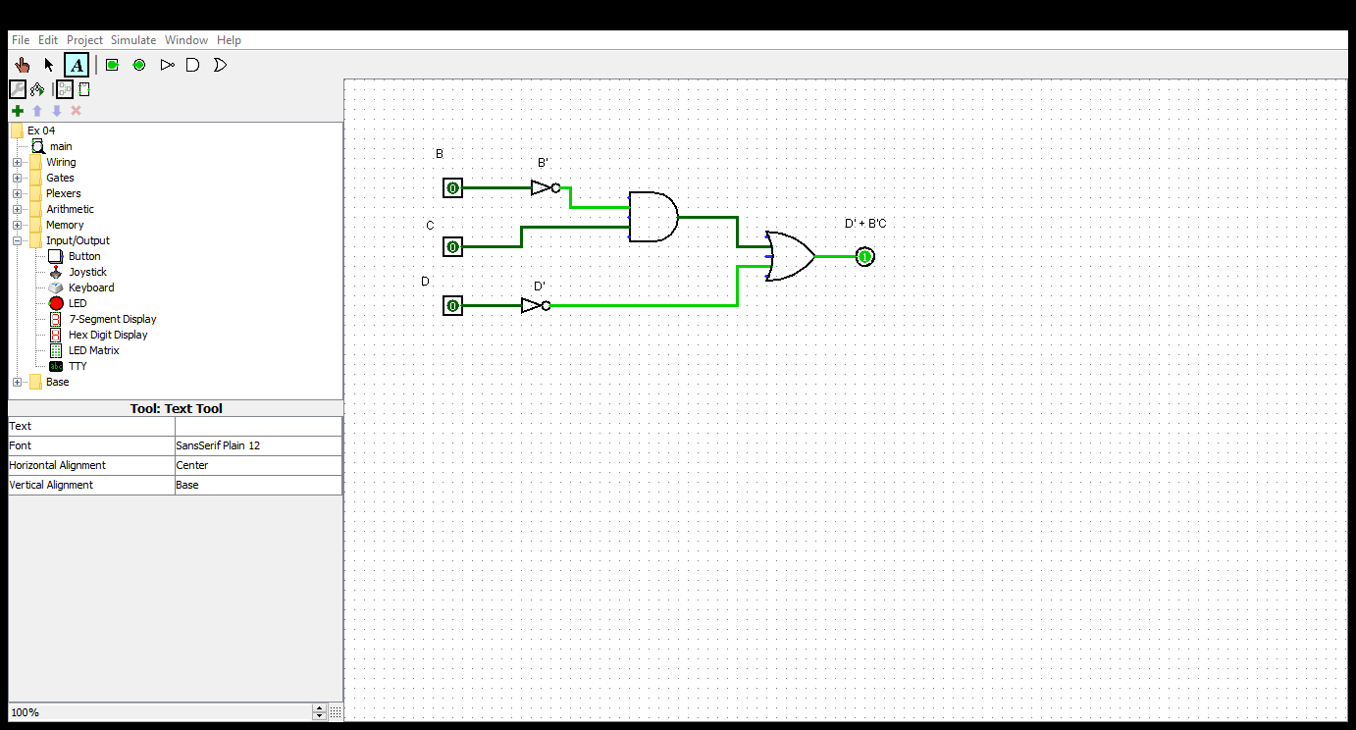

**Question # 05**

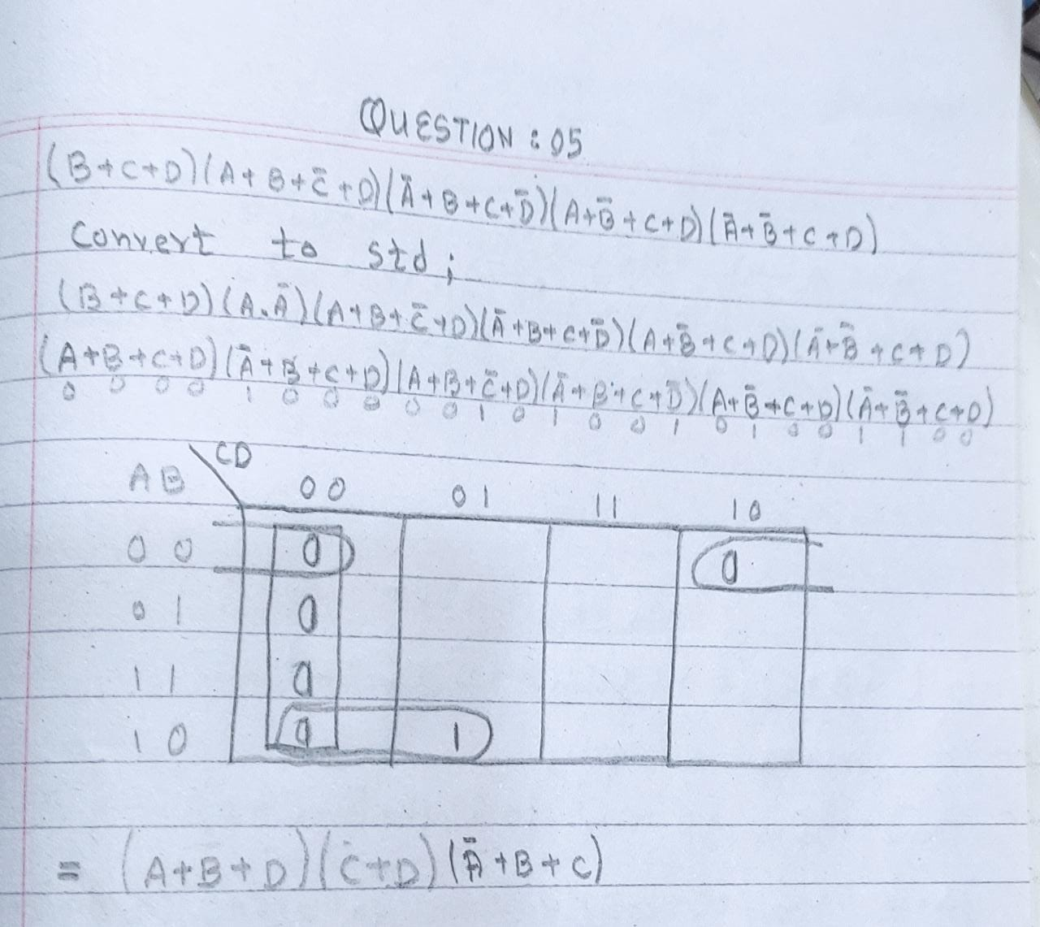

**Truth Table**

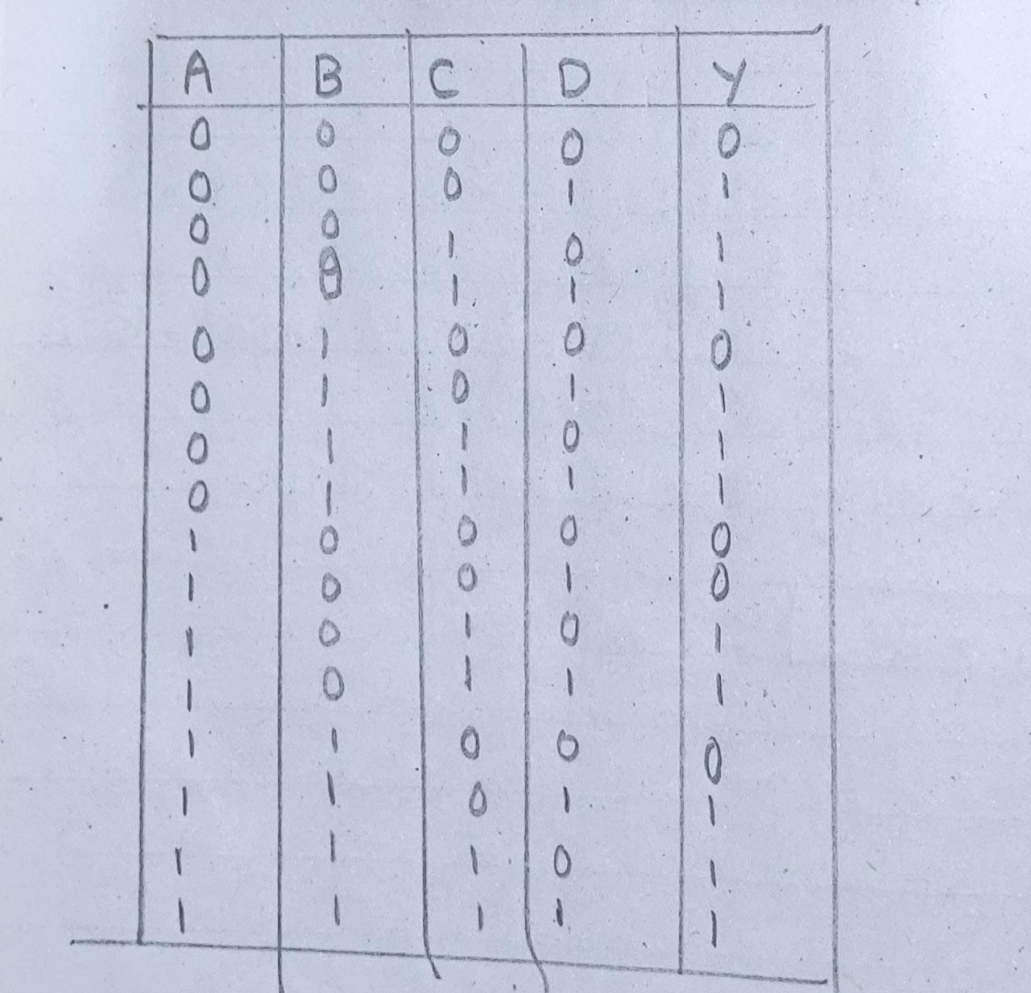

**Minimized POS on Logisim:**

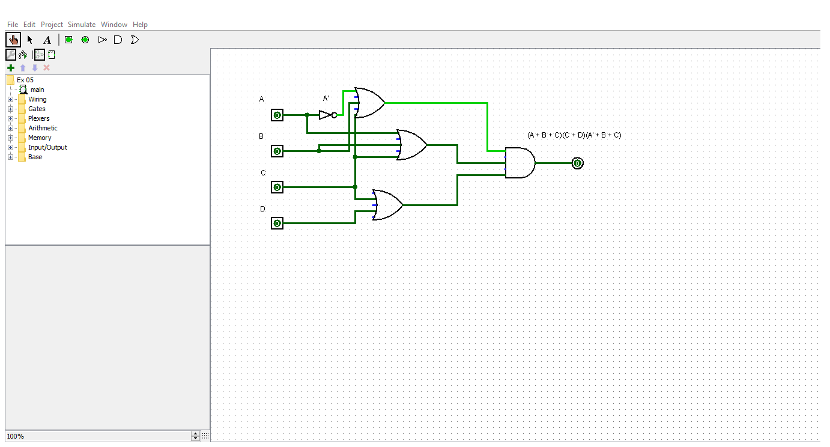

**Question # 06 & 07**

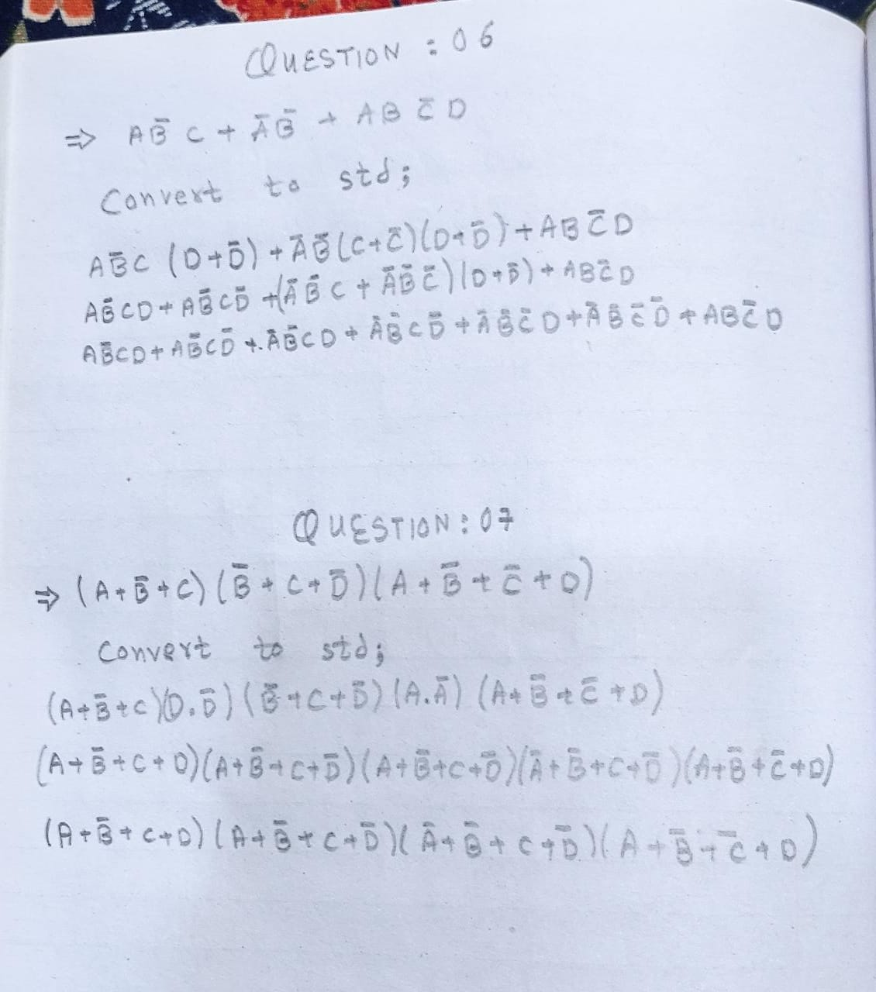

**Implementation of question # 06**

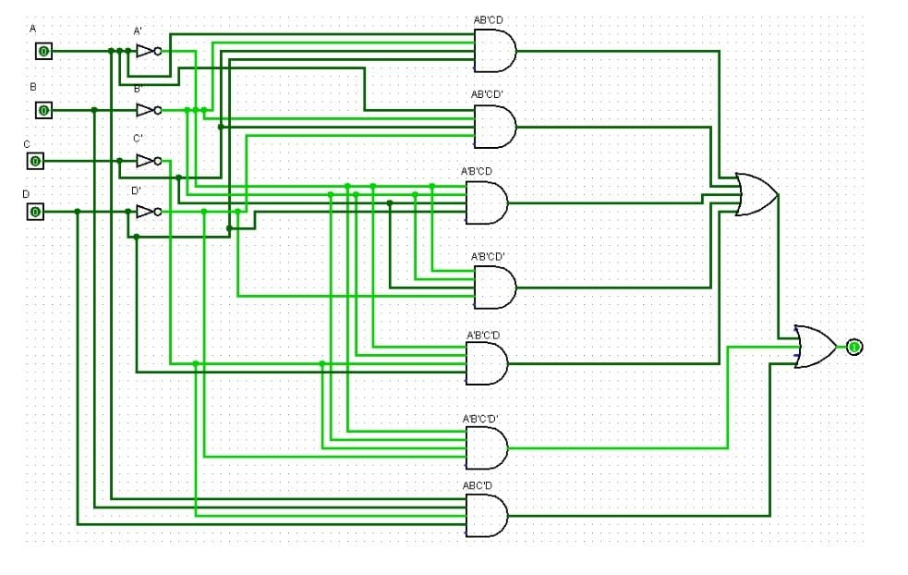

**Implementation of question # 07**

